To all ANSS-Netops members

Hurricane Maria was the worst natural disaster, as I remember in Puerto Rico. Caused a lot of damage in the island. We at PRSN still trying to recover from that disaster. At the beginning, we lost communication with all seismic stations using internet and cellular modem. All our main cellular service companies equipment fail. Up to date we still have one company that is working but with a lot of intermittent. The only stations that survived where the analog ones that I am sending data using VHF and UHF radios. The vault construction that we are using now looks to be good they do not have water inside. Now I am trying to do an inventory of stations that their equipment could be use again. Most of the failures were solar panels and radio antennas they fell down. We are talking about wind speed of more than 175 MPH in some areas. Now I continue trying to visit all the other stations but we still does not have electricity, potable water in some areas and the road and or trails are not in good conditions so many trees down.

I will like to have some suggestion about how improve our communication system before I start requesting quotations. We have around 30 seismic stations including the small islands. About 90% are broadband and 24 bits digitizers. I have been using Wireless 2.4GHZ and 900MHZ radios but they are out now because the lack of electricity and internet. Before I used a microwave path but it was cancel. I have cellular modem with AT&T but this service is down. I am using solar panels and batteries but maybe some of them are not in acquisition mode because the low voltage due to the solar panels are not in place. The following picture will give you an idea of our network. The black icons are RefTek equipment, the orange Q330’s and the green short period.

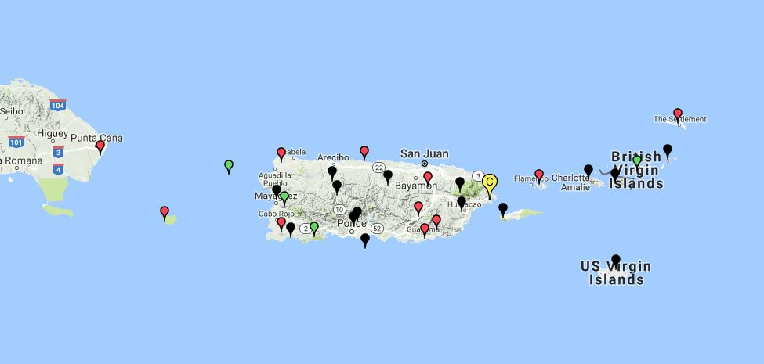

As you can see, we have stations at USA Virgin Islands and British Virgin Islands that I do not know when will be a good time to travel to those places.