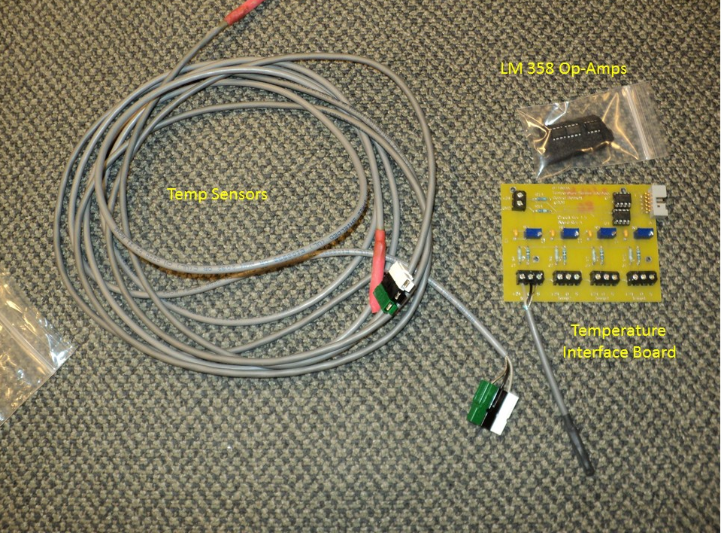
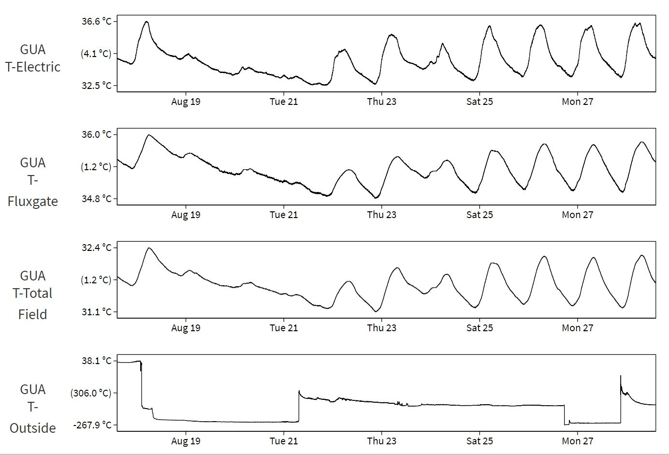

If you haven’t already, you will be receiving a box with the items in the top picture:
- Temperature Interface circuit board.
- 2 – Temperature probes
- 3 – LM 358 Operational Amplifiers (small 8 pin devices).

I am sending these parts because your outside temperature plot shows bad data. Notice the plots in the bottom picture. The bottom plot, labeled GUA T-Outside, shows erratic and erroneous data. You can view the plots yourself, and I would suggest you do this now, so when you are done with this procedure, you will be able to see the results.
https://geomag.usgs.gov/plots/

After you are at this site, click the tab for your observatory (GUA), and scroll to the bottom of the Guam plots. The last 4 plots are the temperatures we maintain for your observatory. The bottom plot, GUA T-Outside, is the temperature in question. After you have successfully repaired this sensor and interface, T-Outside should read about 29 – 31° C.

Please follow the procedure outlined below to remedy this problem.

To do this you will need the following:
- Digital Volt Meter (DVM).
- Small screwdriver, to remove wires from the screw terminals on the Temperature Interface circuit board (Temp Board).
- The contents of the box.
At the Variations Building, inside the NEMA box, find the Temp Board mounted on the left side. There should be three sets of wires attached to each of the 4 screw terminals.

Using the replacement Temp Board I sent for reference, notice the labels below the screw terminals: “+24”, “O” (for Output), and “S” (for Shield). The “S” terminal is Ground. Also, below the labels for the individual terminals, notice the labels for each temperature sensor, 1 through 4. We are concerned with Temp 4, the outside temperature.

Step 1.
At the Temp Board in the NEMA box, attach the black lead from your DVM to the “S” terminal or wire for any of the 4 screw terminals. This will serve as ground for all measurements. Now, measure the voltage on all 12 terminals. Notice the following:
- On the “+24” terminals you should measure about 20 VDC. (> 18 VDC)
- On the “O” terminals, you should read about 3 VDC. (2.9 – 3.2 VDC)
- On the “S” terminals, you should read 0 VDC. (+/- 0.01 VDC)
Because the Outside temperature is bad, be prepared for the voltages measured on the Temp 4 Terminals to be different than the voltages measured on Temps 1-3.

Step 2.
If all the voltages measured on the Temp 4 screw terminals are like the voltages measured on the terminals for the other three temperatures, skip to Step 3.
If any of the voltages on Temp 4 screw terminals measure drastically different from the other three sensor terminations, you have probably found the problem, and it is either the Outside Temperature sensor, or the lead wire from the sensor. Please do the following:
- On the right, outside surface of the NEMA box, locate the Green/Black/White connections where the sensor lead wires are attached to the NEMA box. They should be labeled Fluxgate, Total Field and Outside.
- Disconnect the cable for the Outside Temperature lead wires.
- Plug one of the replacement Temp Sensors into the same connection.
- Repeat the steps associated with the Temp 4 voltage measurements.
- If all the voltages measured on the Temp 4 screw terminals are like the voltages measured on the terminals for the other three temperatures, take everything back to the office, and look at the T-Outside Temperature plot and notice the most recent data registering on the extreme, right side of the plot (the most recent data). It may take up to 5 minutes for this data to appear on the plot. If you have successfully repaired this sensor and interface, T-Outside should read about 29 – 32° C.
- If the T-Outside Temperature now reads about 29 – 32° C, return to the Variations Building, and follow the Outside temperature lead wires to locate the temperature sensor.
- With one of the replacement sensors, replace the sensor, and return to the office to see if the outside temp still is being displayed correctly (29 – 32° C). It may take up to 5 minutes for this data to appear on the plot. If you have successfully repaired this sensor and interface, T-Outside should read about 29 – 32° C, and your job is done.
- If this doesn’t repair the defective temperature readings, inspect the lead wires connecting the temperature sensor to the Green/Black/White connections on the right side of the NEMA box. Note: With the DVM, you can measure the same voltages where the temperature sensor connects to the lead wires. A known good temp sensor must be attached to the lead wires to get the correct voltage. If you have successfully repaired this sensor and interface, T-Outside should read about 29 – 32° C, and your job is done.

Step 3.
If the temperature is still not 29 – 32° C, or the voltage is good, but the plot shows bad Outside Temperature, proceed as follows:
- Notice the Blue/Black twisted pair of wires connected to the 2-screw terminal connection on the upper left side of the Temp Board. This is the power supply input to the Temp Board. This twisted pair might be labeled “3” on both ends. If you notice on the replacement Temp Board, the terminals are labeled “+24” and “GND.” You can either follow the Blue/Black twisted pair of wires back to find the Blue/Black plastic connection to the Power Board (mounted on the upper right side of the NEMA box), or using the screwdriver you brought with you, you can loosen the screw securing the Blue wire to the Temp Board, but care must be taken as you remove the wire to make sure the Blue, +24 VDC power doesn’t short to anything. The result should be removing power from the Temp Board.
- Once power is removed from the Temp Board, using the same small screwdriver, pry the LM 358 Op-Amp from the Temp Board from the socket labeled “U1.” Use the replacement board for reference.
- Using one of the replacement LM 358s shipped to you, paying close attention as to orientation (notice the printing on the component on the replacement board), and making sure all 8 pins are guided into their respective sockets, carefully press the new Op-Amp into place.
- After replacing the Op-Amp. Return to the office, and look at the T-Outside Temperature plot and notice the most recent data registering on the extreme, right side of the plot (the most recent data). It may take up to 5 minutes for this data to appear on the plot. If you have successfully repaired this sensor and interface, T-Outside should read about 29 – 32° C, and your job is done.
- If, at this point the Outside temperature still doesn’t appear normal, reply to all with your findings and questions about anything you don’t understand.

Thank you,
Ed Sauter

