SEPTEMBER MEETING NOTICE
Art Hebrank, Geologist
Site Administrator
Missouri Mines State Historic Site

Presenting:
“Urban Geology of the St. Louis Riverfront”

WHEN: Saturday, September 15, 2007

WHERE: Meet in front of the Old Cathedral at 9:00 a.m. (located on Memorial Drive just south of the Arch) Participants are encouraged to park in the Arch Parking garage located between the Arch grounds and Laclede’s Landing.

http://www.slfp.com/CityScapes.html

Lunch will be at Hannegans- 719 North Second, Street, St. Louis, Missouri 314-241-8877 at 11:30. (On Laclede’s Landing). Participants will be responsible for their own meals. Menu items include: appetizers, soups, salads, sandwiches, pasta. Costs range from $6 to $20. Their website: http://hannegans.admitonevip.com/menu.php

Map and directions below.

COST: Expenses for participants will include parking (Arch parking is recommended and lunch) Guidebook for the field trip is $10.00.

RESERVATIONS: Required by Friday, September 14, 2007.
Call, e-mail, or mail this form to Martha Kopper R.G.
Phone: (314) 420-8422
E-mail: Martha.kopper@ewgateway.org
Fax: (314) 244-9611

Please reserve my seat(s) at the September 2007 AEG meeting.
Name(s) ____________________________________________________________________________
____________________________________________________________________________
Company ____________________________________________________________________________

Presentation Summary

The walking tour will begin at the Old Cathedral at 9:00 am. The tour will be lead by Art Hebrank, geologist and Site Administrator of the Missouri Mines State Historic Site. Mr. Hebrank will discuss the urban geology of the St. Louis riverfront and the historic era in which the buildings were constructed. He will focus on selected structures/buildings, the type of stone used, where it was quarried, types of masonry. This excellent walking tour was well attended by regional science teachers six years ago at a national AIPG/AEG conference held in St. Louis.

Directions to Arch Parking Garage
______________________________________________________________________________________________
From Lambert International Airport (North)
Traveling east on I-70, take the Memorial Drive-Downtown Exit (250B). Travel through one stoplight (Pine St.), then turn left on Chestnut. Cross over the highway then turn left on Memorial Drive. Stay in the right lane and turn right on Washington Avenue. Traveling east, the garage is on the right.
From Illinois (East)
Traveling west on I-64, I-55/70 cross the Poplar Street Bridge. Take the Memorial Drive/Arch Riverfront/Convention Center Exit Only (right lane). Garage parking and the riverfront are accessible by traveling past the Arch and taking the first right onto Washington Avenue. Traveling east, the garage is on the right.
From South St. Louis
Traveling north on I-55 and I-44 (I-44 East merges with I-55 North) take the Downtown Exit (209A) and then take the Memorial Drive Exit (251C) which is the 2nd right-hand lane (the far right lane goes to Illinois). Garage parking and the riverfront are accessible by traveling past the Arch (right lane) and taking the first right (Washington Avenue). Traveling east, the garage is on the right.
From West St. Louis
Traveling east on I-40 take the Broadway Exit (last Missouri Exit-40B). At the stoplight at the end of the ramp turn left. Go through one stoplight then turn left onto Fourth Street at the second stoplight and travel north to Walnut. Turn right on Walnut and travel east to Memorial Drive. Turn left on Memorial Drive. The Arch garage is past the Arch (traveling north). Turn right on Washington Avenue. Traveling east, the garage is on the right.
MetroLink
The Jefferson Memorial is easily accessible from St. Louis' MetroLink Lightrail. Board at any station and exit at Laclede's Landing and follow the signs to the Memorial (a five minute walk). The trip from Lambert National Airport to Jefferson National Expansion Memorial is 28 minutes, with departures to and from Lambert every 10 minutes.
Parking
Paid parking is available in the Arch Parking Garage located on the north edge of the Arch grounds off of Washington Avenue. Parking is $6 for the first 9 hours and 75 cents for each additional half hour. The garage has an Early Bird special of $4 for those entering the facility between the hours of 6:00 a.m. - 9:00 a.m. Maximum vehicle height is seven (7) feet.
The Old Courthouse is located adjacent to many public parking areas within one to two city blocks.
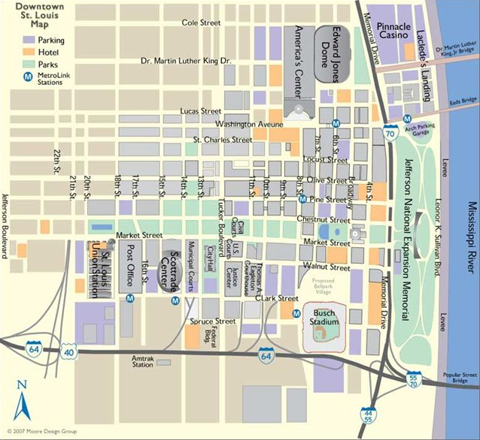

This e-mail is being sent as a courtesy to AEG members. If you no longer wish to receive emails from the Association, please email aeg@aegweb.org and write “Please remove my email” in the subject line.

