2006 Earthquake Insight Field Trip – October 13
St. Louis Area Earthquake Hazards Mapping Project

WHO? This field trip is for those in business operations, finance, lending, equity, public service, insurance, utilities, communication, planning, transportation, and related fields; also for elected officials and local media. It is for those who want to learn about how earthquake hazards and earthquake risk affects the St. Louis area.
Phyllis Steckel, a registered geologist under contract with the US Geological Survey, will lead this field trip. Other presenters include active professional engineers and geoscientists working on the central US earthquake issue.

WHAT? This is a one-day field trip through St. Louis city and north St. Louis County to places that illustrate the story of earthquake hazards and earthquake risk here. This is the first of what is planned to be an annual outreach event for the St. Louis Area Earthquake Hazards Mapping Project. This project is led by the US Geological Survey, in partnership with several local universities, state agencies, and private-sector organizations.

WHEN? Friday; October 13, 2006 – 7:45 am until 4:30 pm

WHERE? Depart from the north side of Laclede Avenue, just east of Grand Avenue, on the campus of St. Louis University. The route includes downtown St. Louis and the area of Chouteau’s Pond; Columbia Bottom; Fort Bellefontaine; Lambert-St. Louis International Airport area; Earth City; Maryland Heights; and Dogtown.

WEAR? Dress-down in comfortable clothes and shoes. There is an optional short walk in brush or high grass at one stop.

HOW? Travel will be on an air-conditioned, restroom-equipped bus. At several stops and along the way, engineers and geoscientists will discuss the earthquake issue and explain what is being done to reduce risk – and what still needs to be done. There will be time for informal discussion. A guidebook and lunch will be provided.

HOW MUCH? Cost is $40 per person.

REGISTER? Call or email Phyllis Steckel to reserve your space. Then send your check (payable to Earthquake Insight) to Earthquake Insight; PO Box 2002; Washington, MO 63090.

SPONSORS? A limited number of corporate sponsorships are available for $300 each, which includes prominent recognition for each sponsor and registration for four participants – such as clients or potential clients.

DEADLINE? Sign-up by Friday, October 6, 2006.

QUESTIONS? Contact Phyllis Steckel for questions or special needs at 636-239-4013 or psteckel@charter.net.

Comments from the 2005 Earthquake Insight Field Trip participants….

“Very well done. I learned so much and having actual professionals/leaders in their perspective fields was awesome.” “The speakers were great and communicated so we could understand. Everyone loves the hands-on field trip. Phyllis did a great job in a difficult logistics effort. I will use this information for education purposes with my customers.” “…I can’t express enough how much I enjoyed the experience. The knowledgeable presenters, the great locations chosen,….” “Very pleasantly surprised to find the geologists & people involved in earthquake hazard reduction effort very knowledgeable and very nice! Thank you so much.”

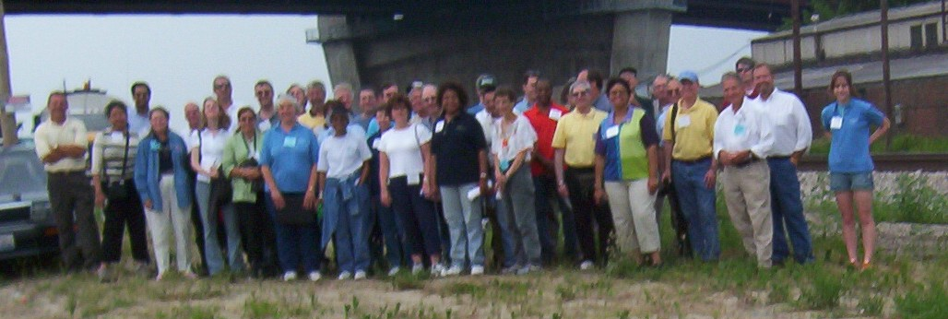

2005 Earthquake Insight Field Trip participants at the Emerson Bridge, in Cape Girardeau, Mo.
http://erp-web.er.usgs.gov/reports/abstract/2005/cu/05HQGR0014.pdf

